Clarification 1: Compliance Scope Calculations for the ‘Data Subject Type’

The NA Data for the ‘Data Subject Type’ is having the Data as ‘Consumer, Employee, Job Applicant, Other, Temp/Contractors, Visitors AND Influencers’ and we do have the condition as

Exclude if Data Subject Type = Employee, Job Applicant, Temp, Contractor, Visitor Include all remaining Data Subject Types.

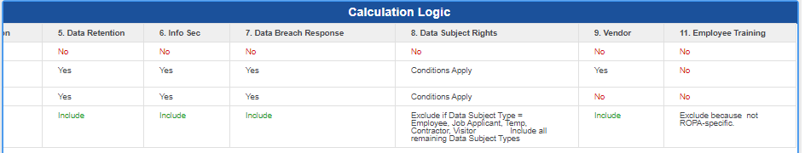

However in the Brazil, we do have the ‘Data Subject Type’ as ‘Consumer, Employee and UNSPECIFIED’ .

Do the Condition or Logic remains same for the Brazil similar to CCPA-NA?

Clarification 2: Repository Type

In NA we do have both Repository Type and Repository Sub Type and respective calculations.

Ex: In the Quality Cockpit, we do have the Vital Error as ‘Missing Repository Sub-type’: When [RepositoryType] "Digital", [Subtype] must be populated.

However in the Brazil : we do have the ‘Repository Type’ attribute only , please review and confirm ?

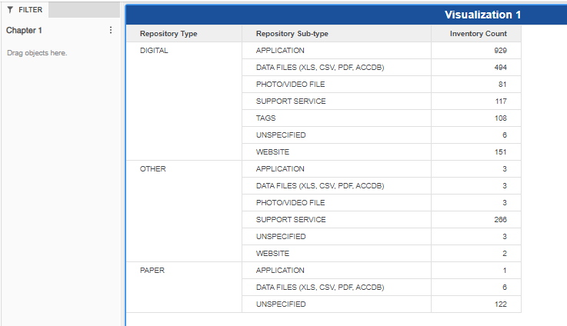

3.

Two new attributes other than CCPA-NA:

Decommission Description

Point of collection